SARAH C. JENSEN RT(R)
11130 Zion St NW
Coon Rapids, Minnesota 55433
(763) 222-4829
sarahc9777@q.com

May 6, 2017

Dear Hiring Manager,

I am a graduate of Century College and have an Associate in Applied Science degree. I am about to start at Metropolitan State University to complete my bachelor’s degree in Business Administration. Through my previous work experience, as well as my education, I feel like I would be an excellent fit for any open administrative position at St. Paul Radiology.

I have been working for the University of Minnesota Physicians for the last three years as a Procedure Scheduler. My responsibilities included registration, making general and complex radiology appointments, helping customers with any questions they may have, registration of new patients and updating existing patients information, front desk, and working on insurance authorizations. I have also assisted in the training of new employees and the interview process.

I have four years of experience in a clinic where I answered an eight-line phone system, directing the calls to the correct department or taking messages for our doctors and staff. I was responsible for filing and pulling charts, as well as scanning insurance cards, referrals and doctor’s letters into our computer system, creating Jpeg files for the scanned documents and assigning to the patients EMR. I worked at the front desk doing patient registration, verifying insurance, making sure that the paperwork was filled out correctly. I also assisted in scheduling appointments and doing any other miscellaneous duties that were assigned to me.

I am a highly motivated individual, who strives to continually improve and grow professionally. I am able to prioritize and multitask. I am a go-getter that is able to get along with anybody. I thrive when I am kept busy, so I am constantly looking for projects. Through my previous employers, I have learned how to listen to the client, figure out what their concern is and solve it. I want each person to leave feeling that they or their loved one received top-notch care from me. I am very adaptable; I can work independently or on a team, although my preference is to work independently. I am personable and will go the extra mile to help out anybody.

Please take a moment to review my resume. I hope you find that my qualifications will meet the needs of St. Paul Radiology. I look forward to meeting with you personally and can be reached at (763) 222-4829 or by email: sarahc9777@q.com.

Sincerely,

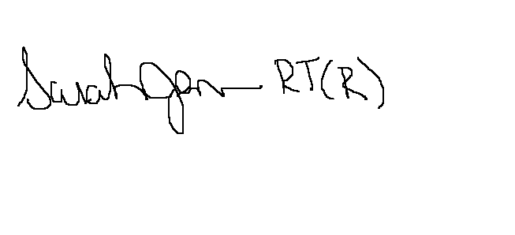

SARAH C. JENSEN RT (R)

Enclosure: Resume

